<https://www.youtube.com/watch?v=Xm2C_gTAl8c&list=PLblh5JKOoLUICTaGLRoHQDuF_7q2GfuJF&index=21>



Today we're gonna talk about ridge versus lasso regression and the differences are going to be visualised.

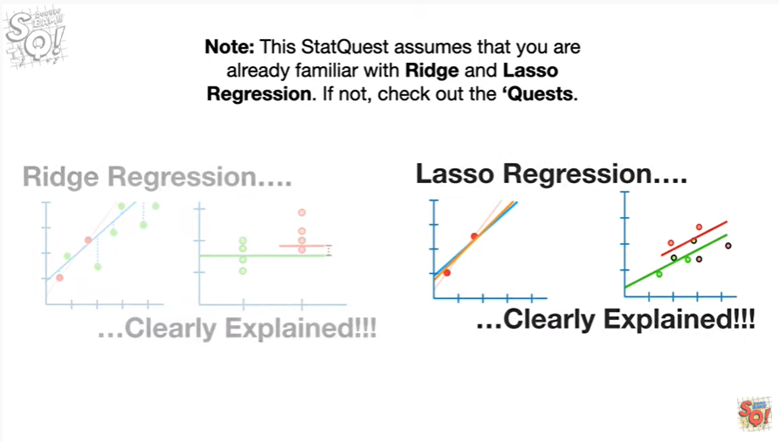

Note : this stack quest assumes that you are already familiar with ridge and lasso regression if not check out the quests.

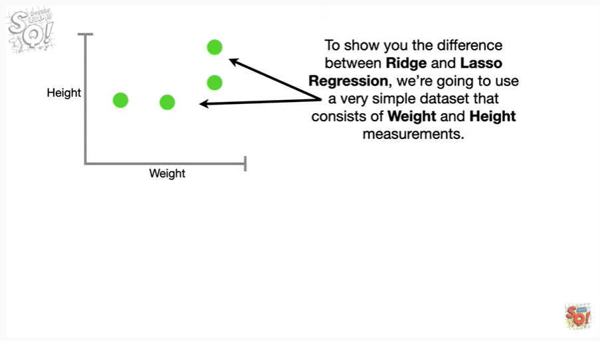

To show you the difference between Ridge and lasso regression we're going to use a very simple dataset that consists of weight and height measurements.

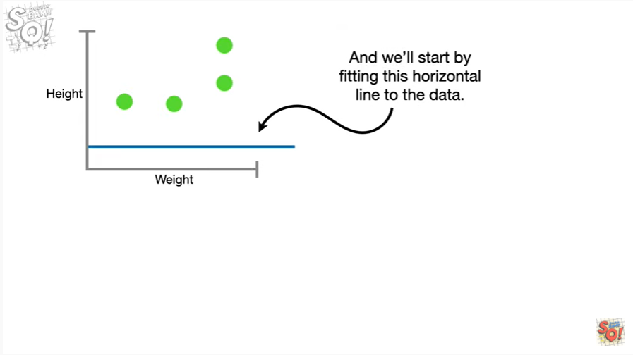

And we'll start by fitting this horizontal line to the data.

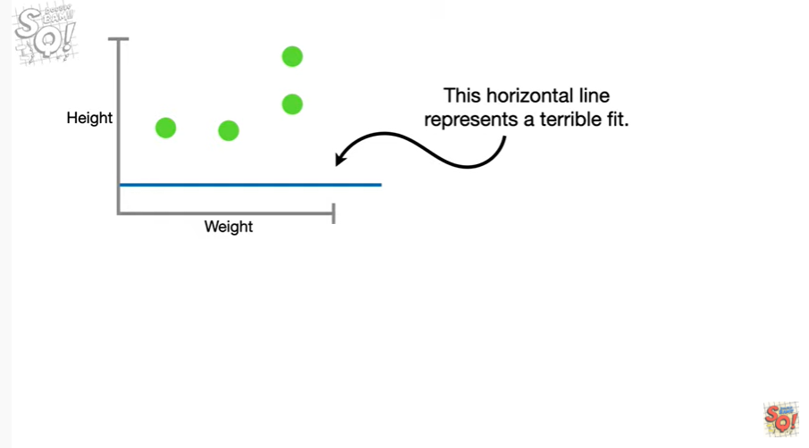

This horizontal line represents a terrible fit.

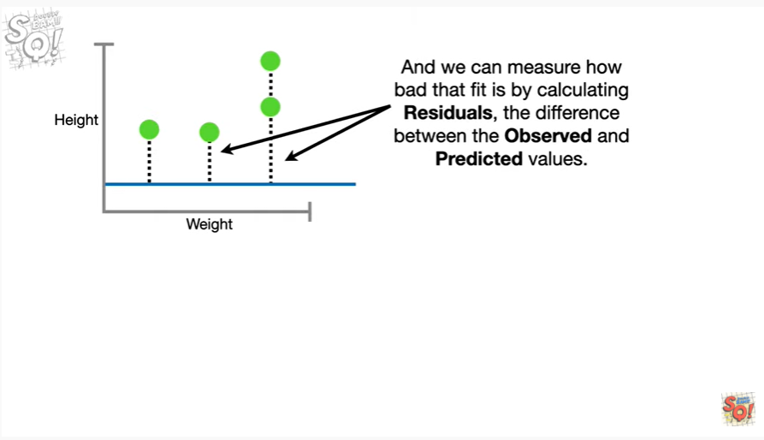

And we can measure how bad that fit is by calculating residuals the difference between the observed and predicted values.

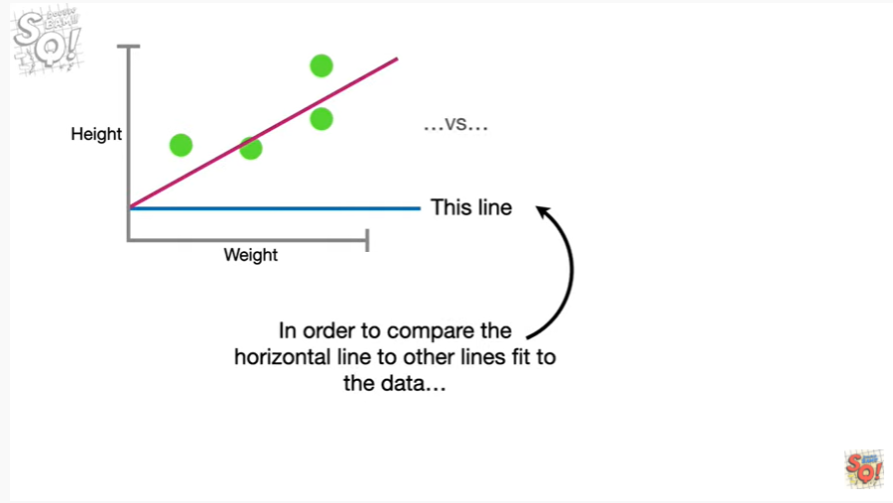

In order to compare the horizontal line to other lines fit to the data

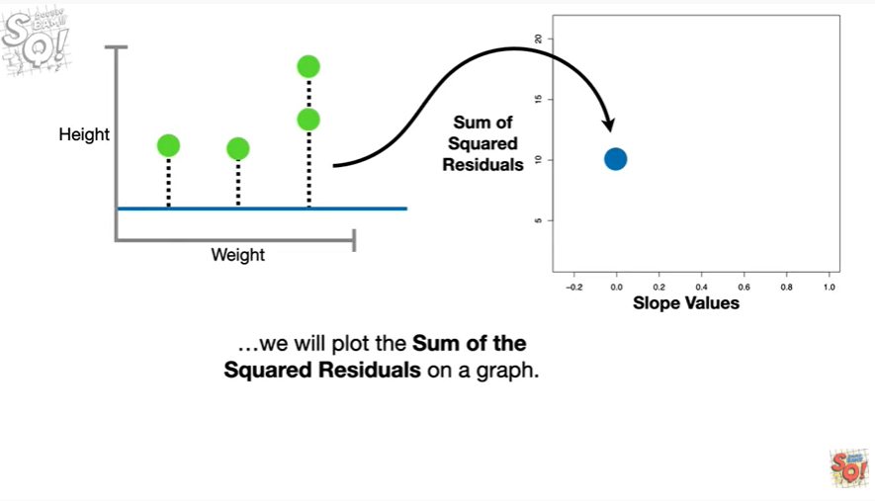

we will plot the sum of the squared residuals on a graph.

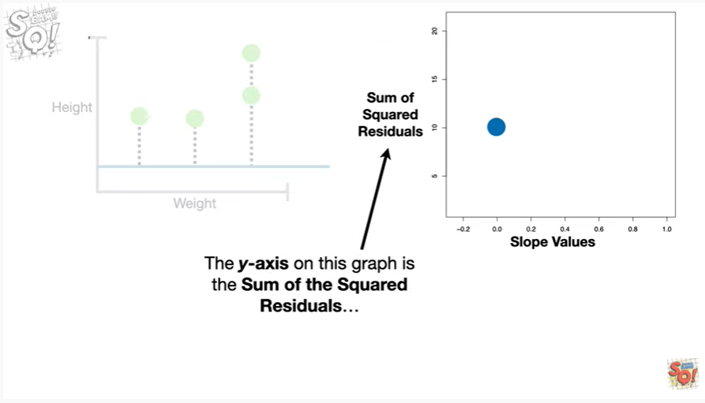

The y-axis on this graph is the sum of the squared residuals

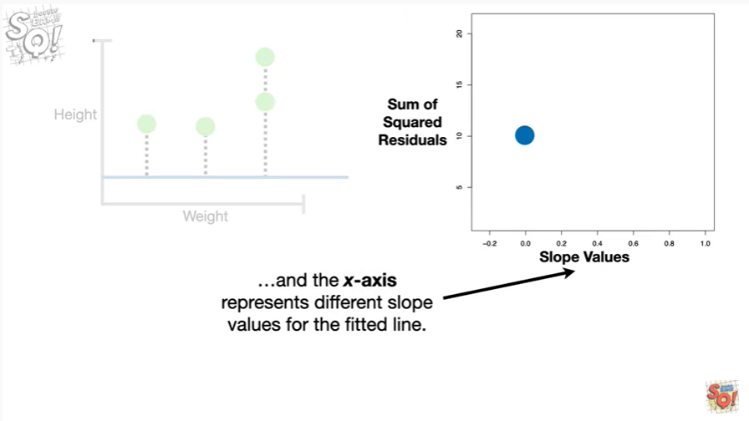

and the x-axis represents different slope values for the fitted line.

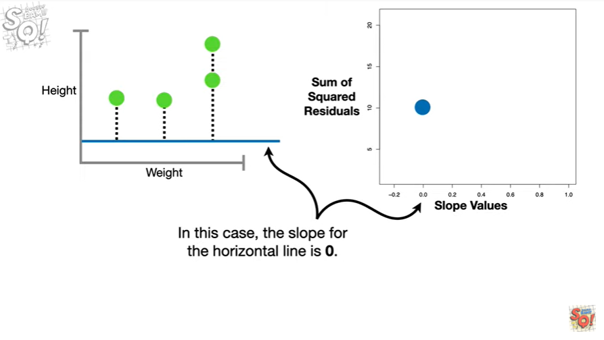

In this case the slope for the horizontal line is zero.

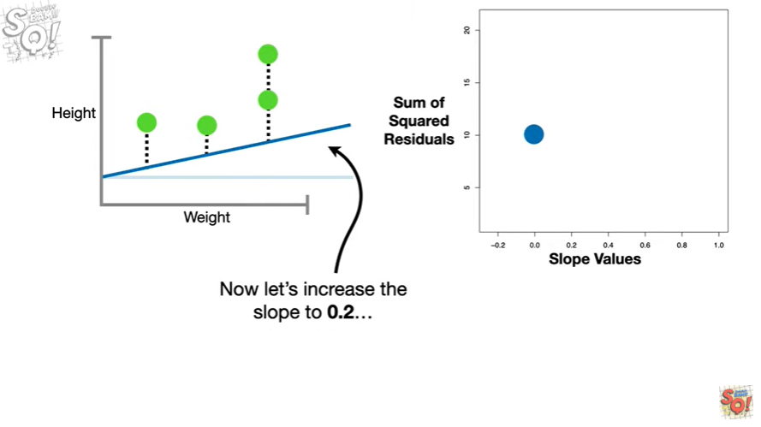

Now let's increase the slope to zero point two

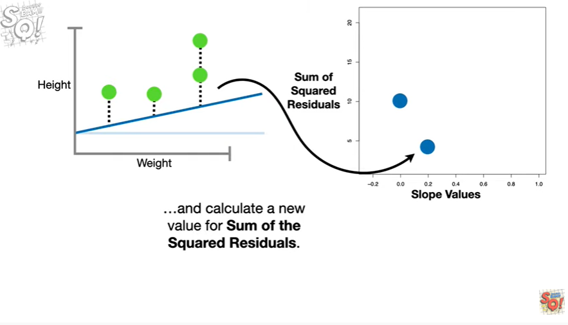

and calculate a new value for the sum of the squared residuals.

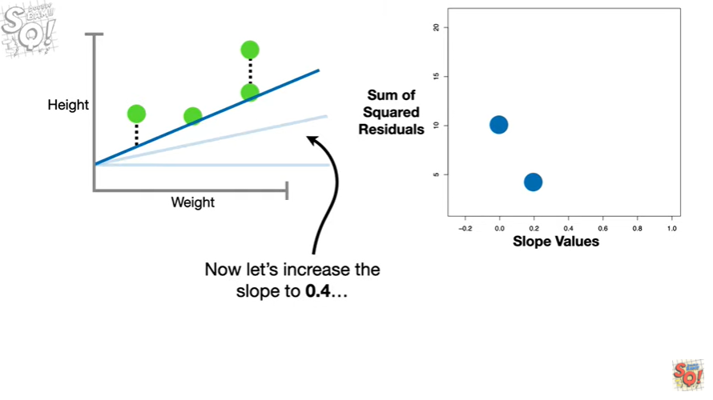

Now let's increase the slope to zero point four

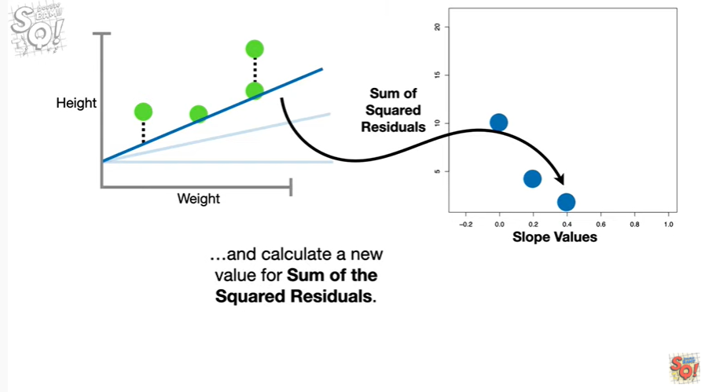

and calculate a new value for the sum of the squared residuals.

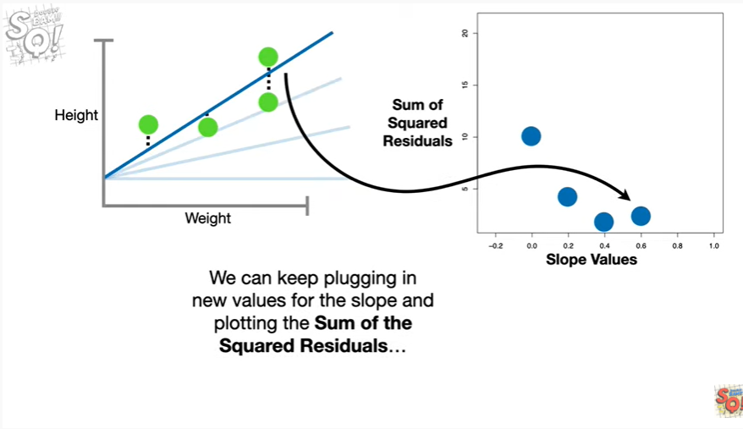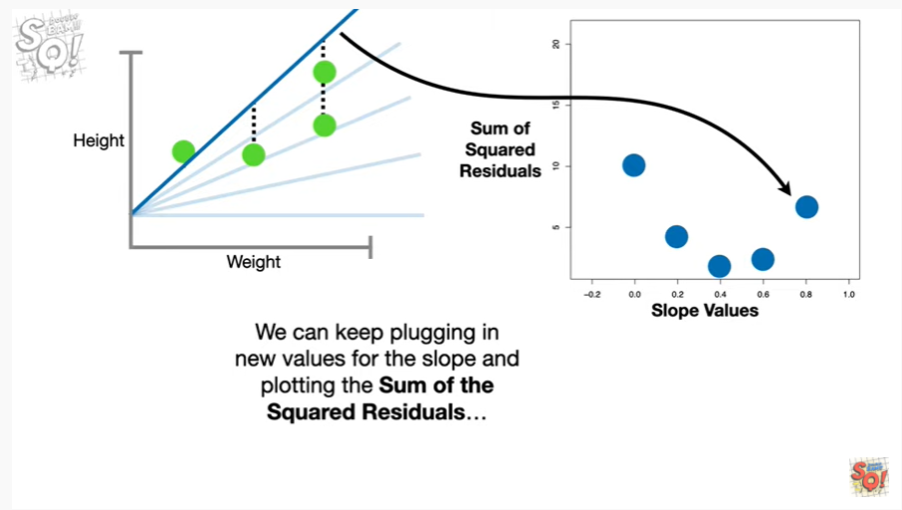

We can keep plugging in new values for the slope and plotting the sum of the squared residuals

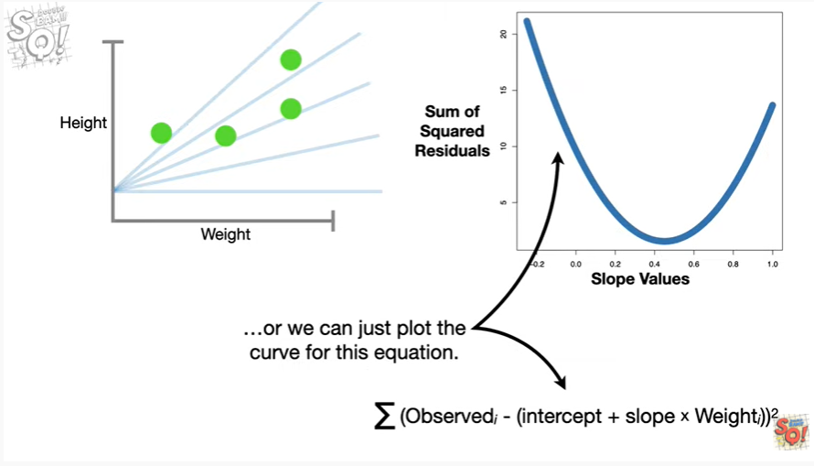

or we can just plot the curve for this equation.

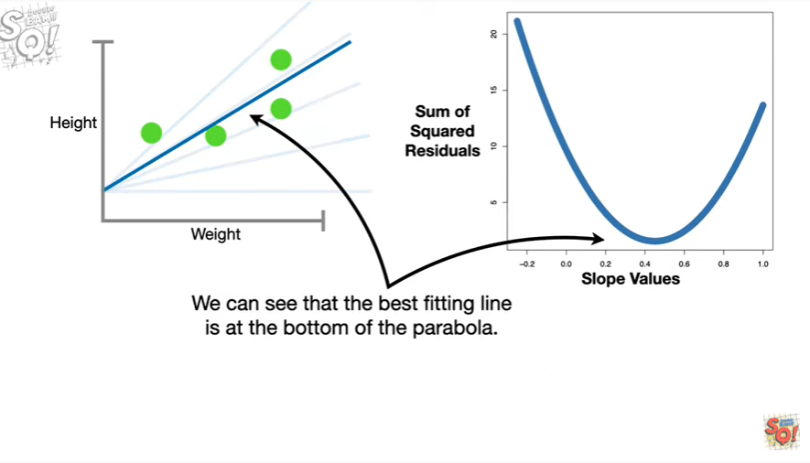

We can see that the best fitting line is at the bottom of the parabola.

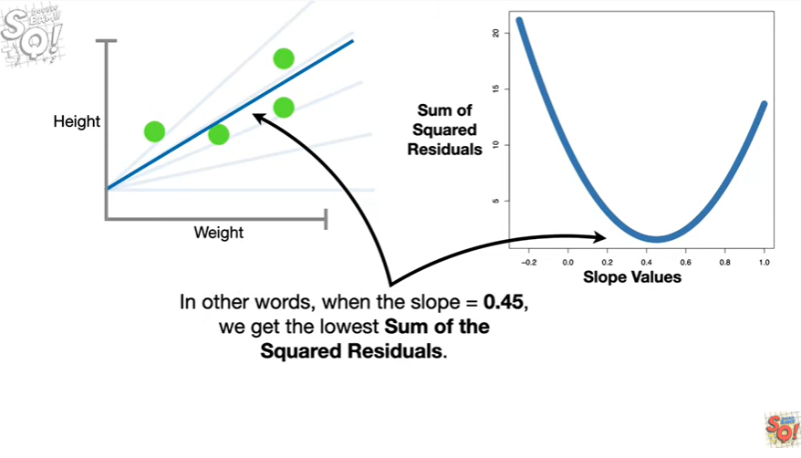

In other words when the slope equals 0.45 we get the lowest sum of the squared residuals.

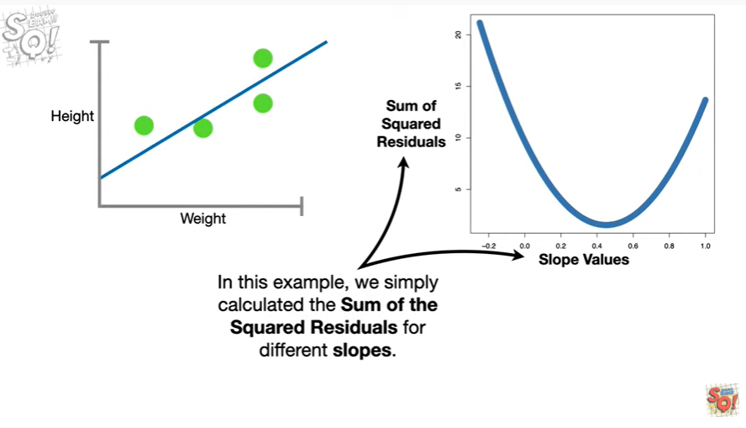

In this example we simply calculated the sum of the squared residuals for different slopes.

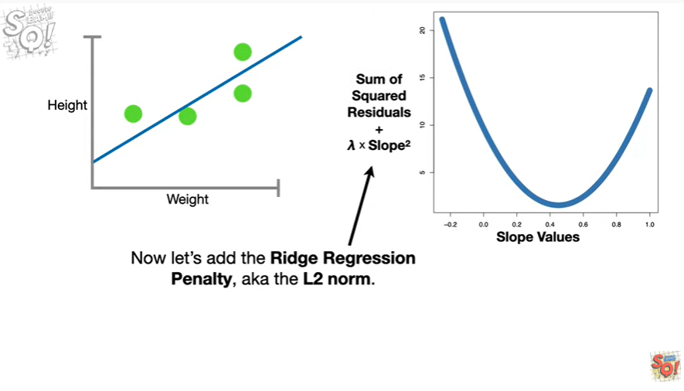

Now let's add the ridge regression penalty aka the l 2-norm.

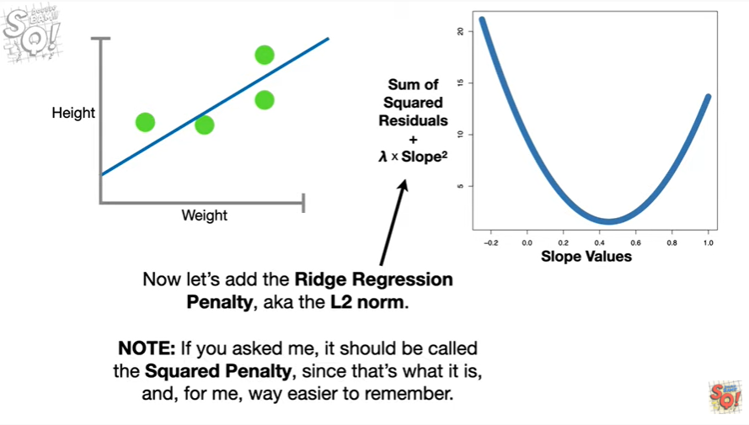

Note : if you asked me it should be called the squared penalty since that's what it is and for me way easier.

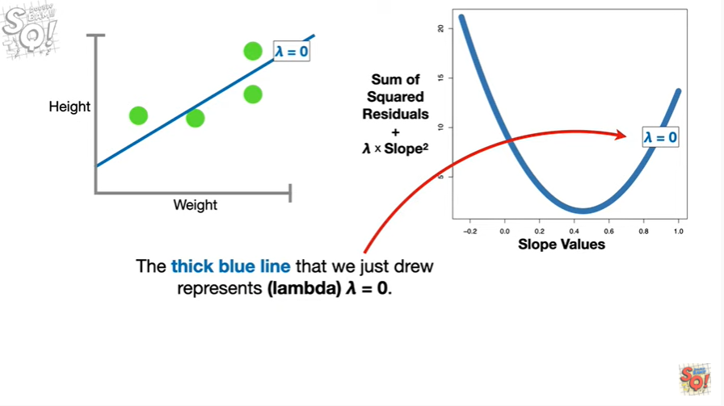

To remember the thick blue line that we just drew represents lambda equals zero.

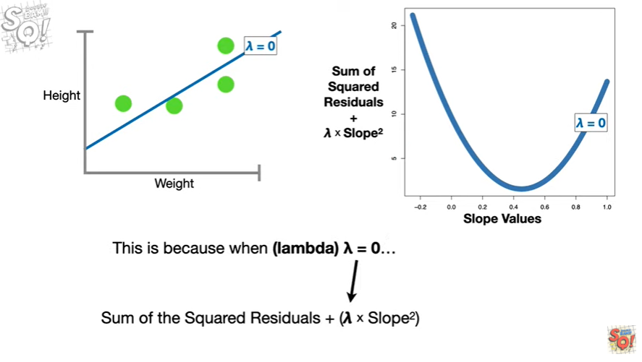

This is because when lambda equals zero

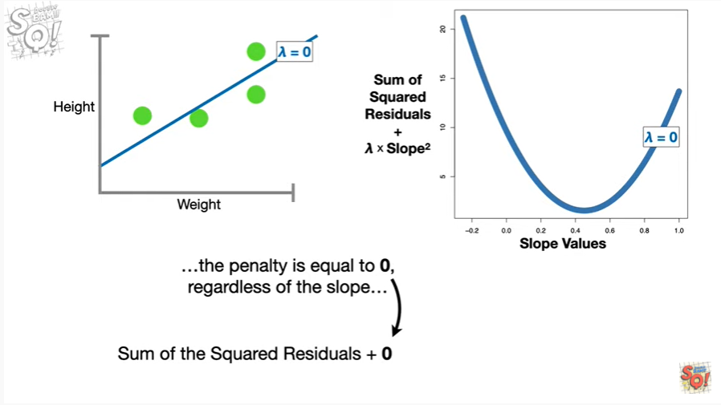

the penalty is equal to zero regardless of the slope

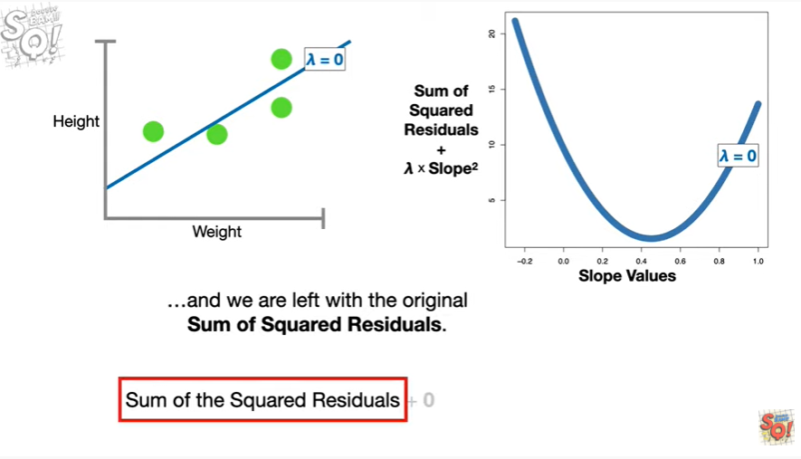

and we are left with the original sum of squared residuals.

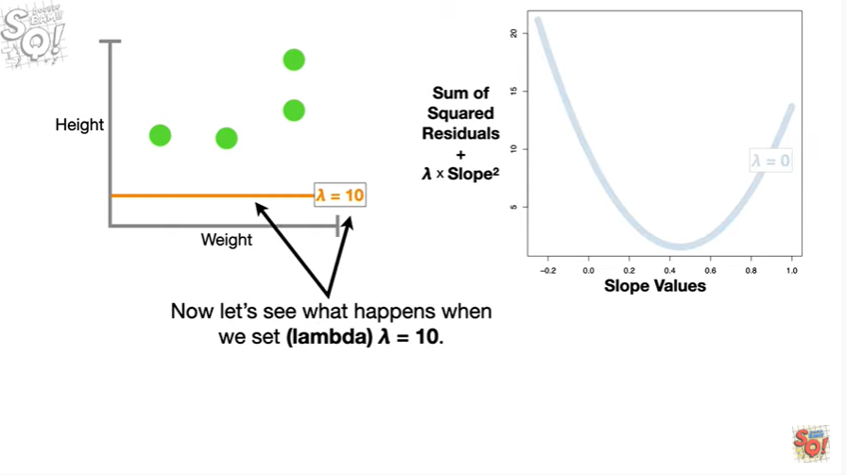

Now let's see what happens when we set lambda equal to 10.

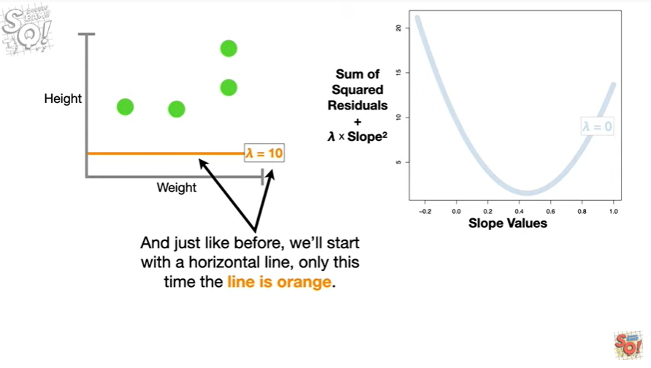

And just like before we'll start with a horizontal line only this time the line is orange.

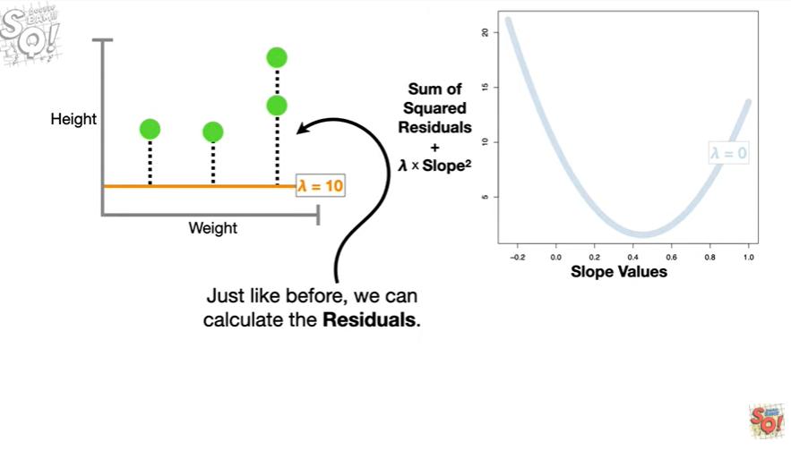

Just like before we can calculate the residuals

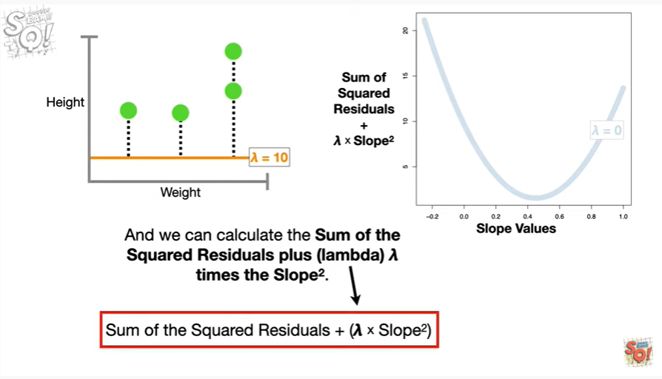

and we can calculate the sum of the squared residuals plus lambda times the slope squared.

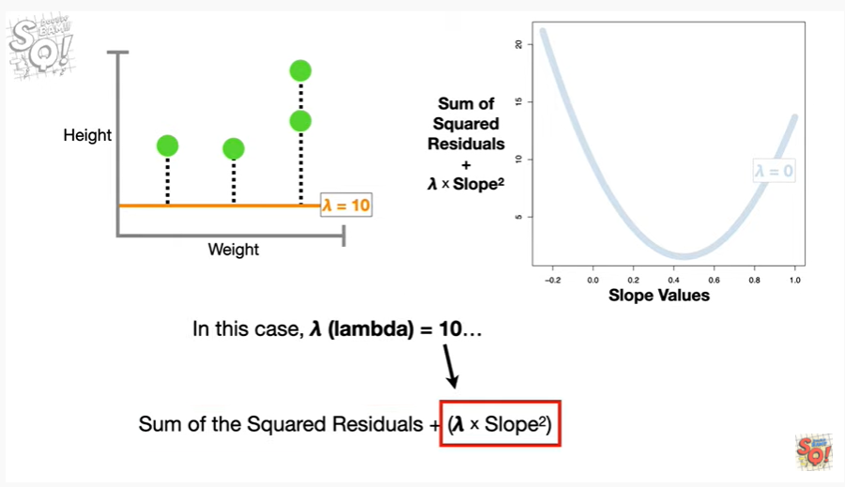

In this case lambda equals 10

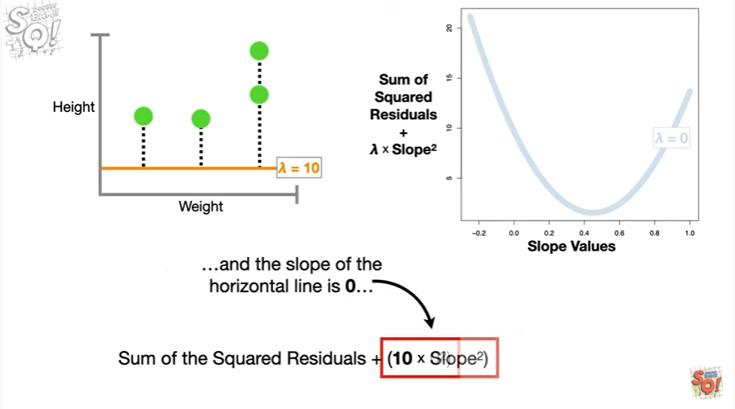

and the slope of the horizontal line is 0

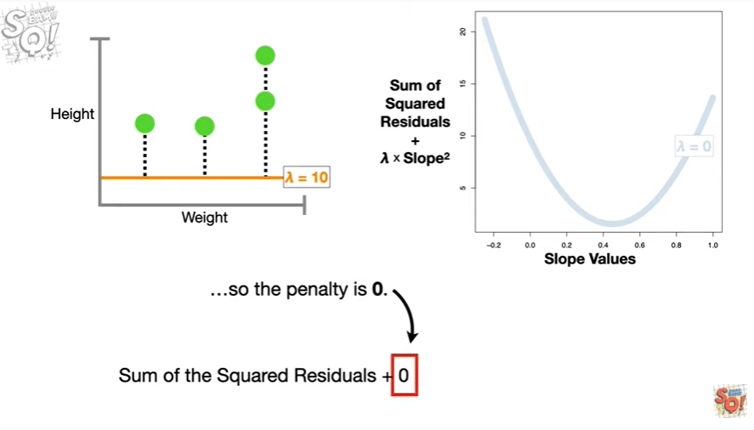

So the penalty is 0.

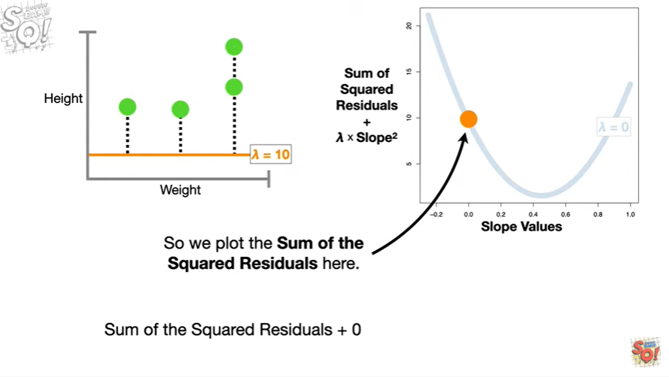

So we plot the sum of the squared residuals here.

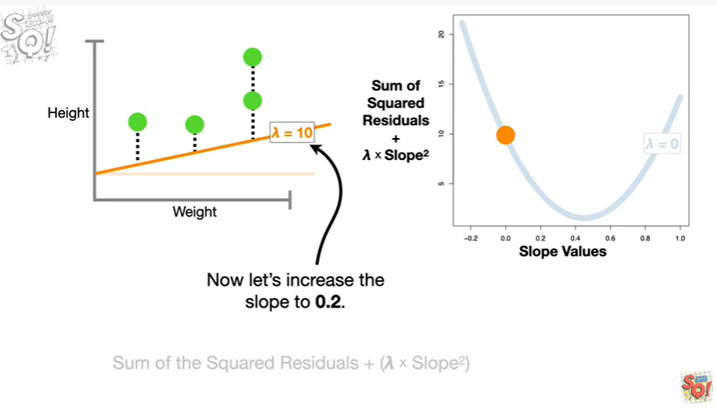

Now let's increase the slope to 0.2.

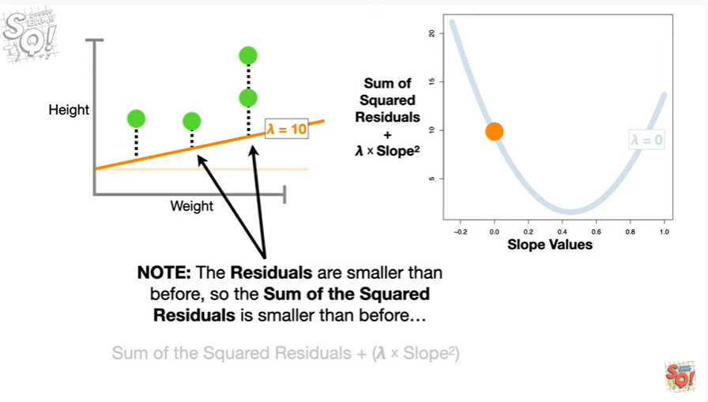

Note : the residuals are smaller than before so the sum of squared residuals is smaller than before

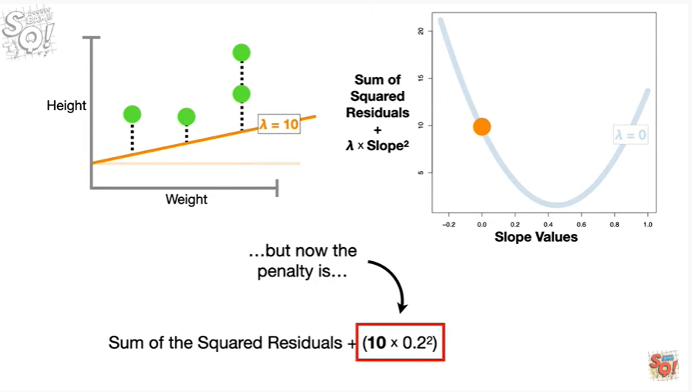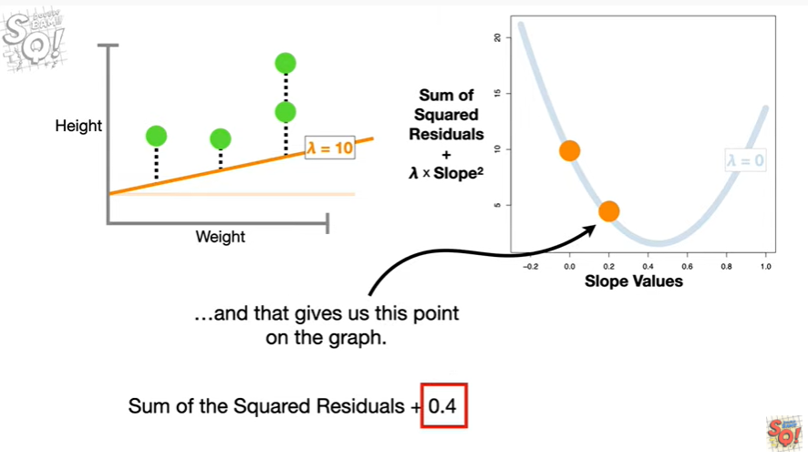

but now the penalty is 0.4

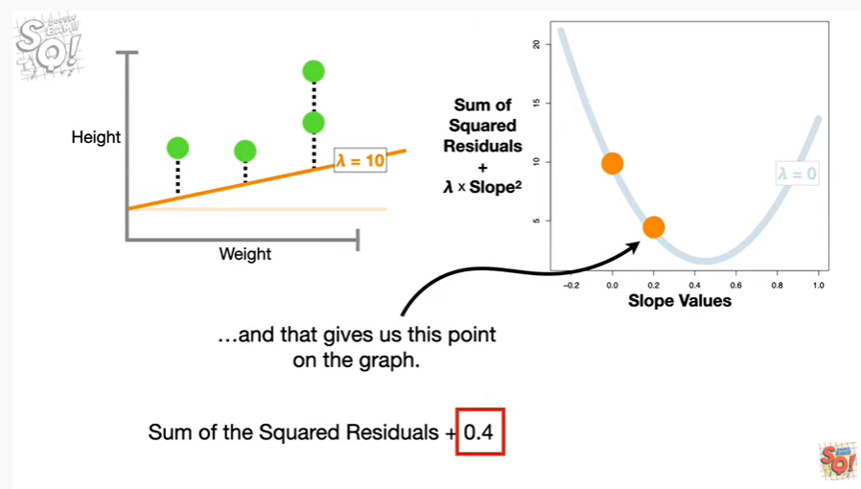

and that gives us this point on the graph.

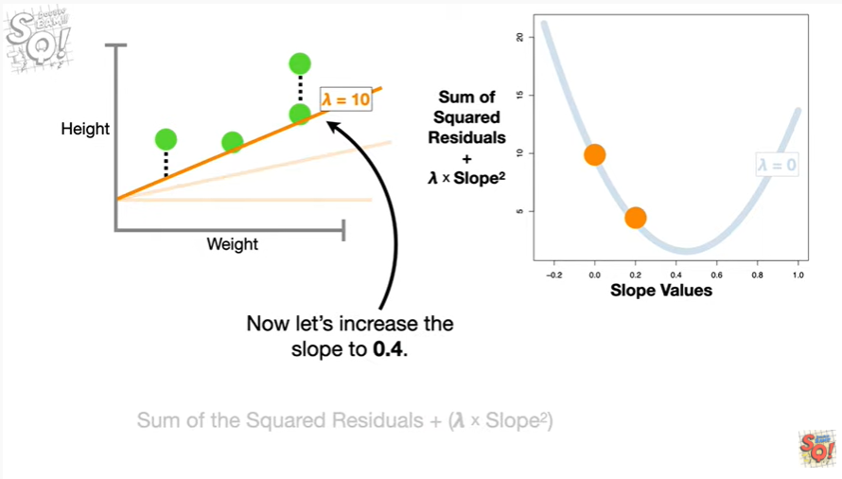

Now let's increase the slope to 0.4.

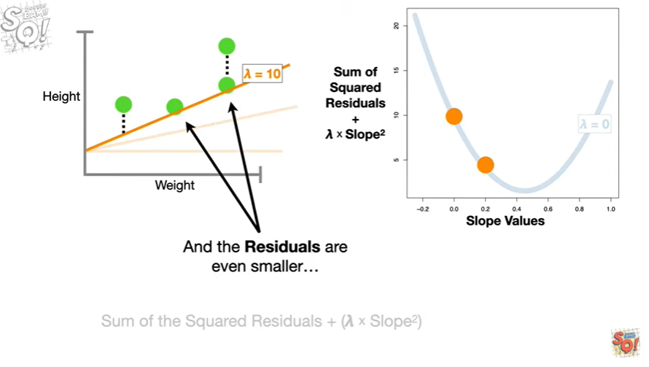

And the residuals are even smaller

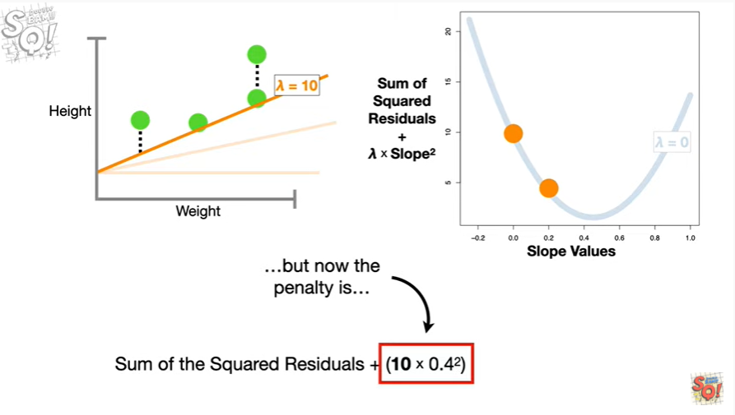

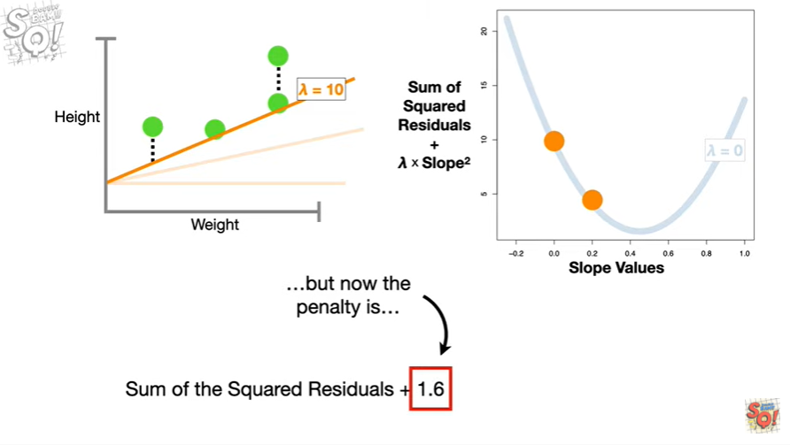

but now the penalty is 1.6

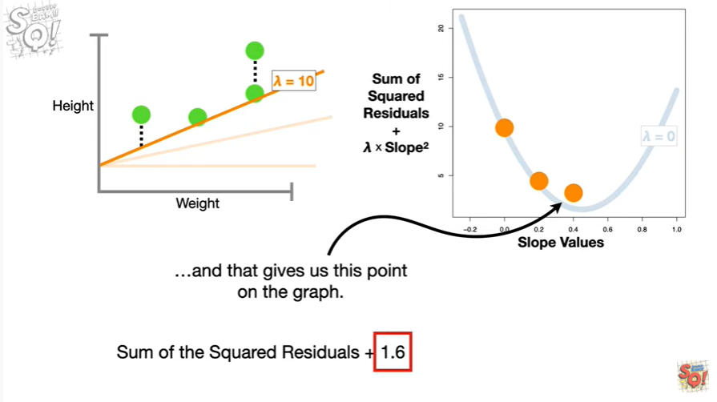

and that gives us this point on the graph.

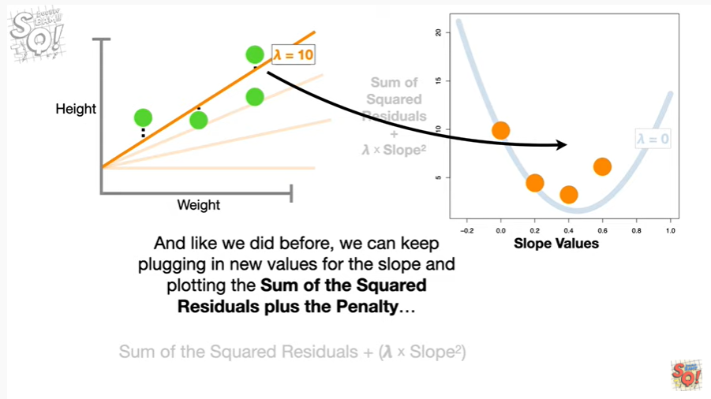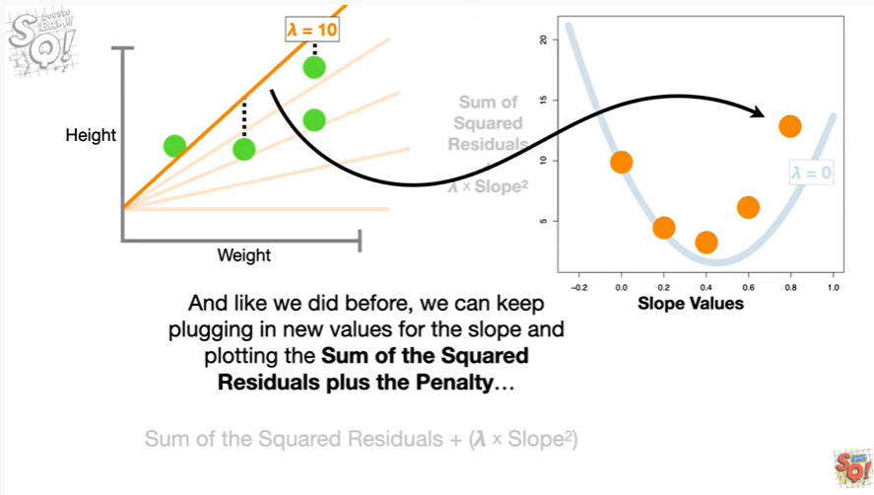

And like we did before we can keep plugging in new values for the slope and plotting the sum of the squared residuals plus the penalty

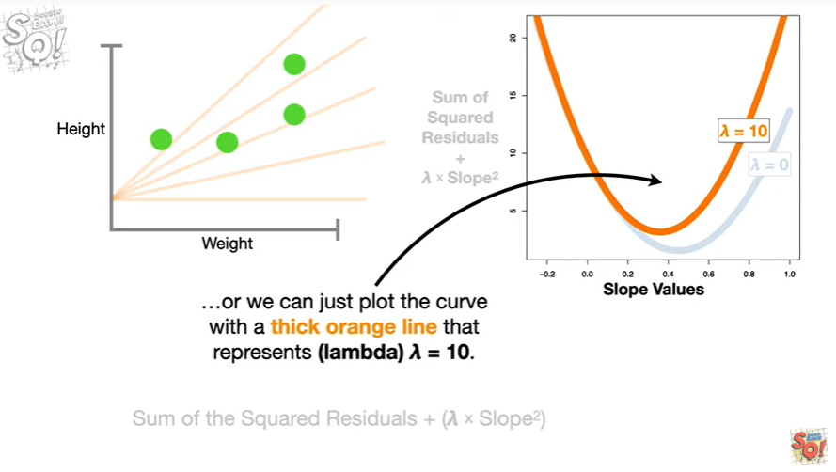

or we can just plot the curve with a thick orange line that represents lambda equals 10.

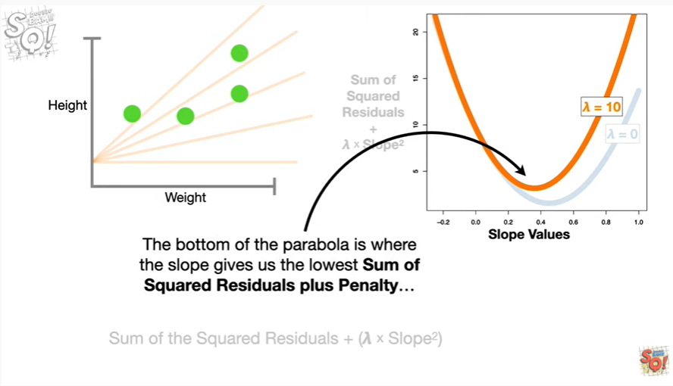

The bottom of the parabola is where the slope gives us the lowest sum of squared residuals plus penalty

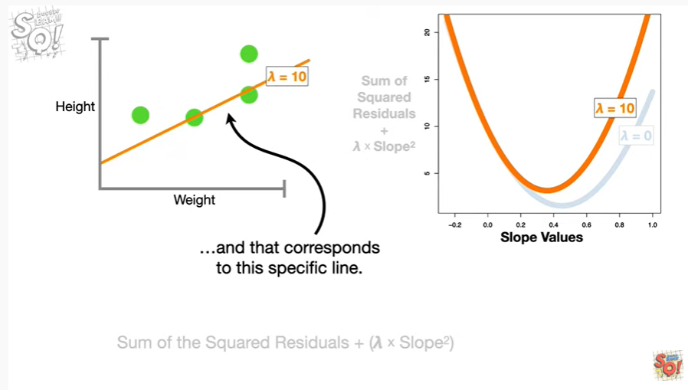

and that corresponds to this specific line.

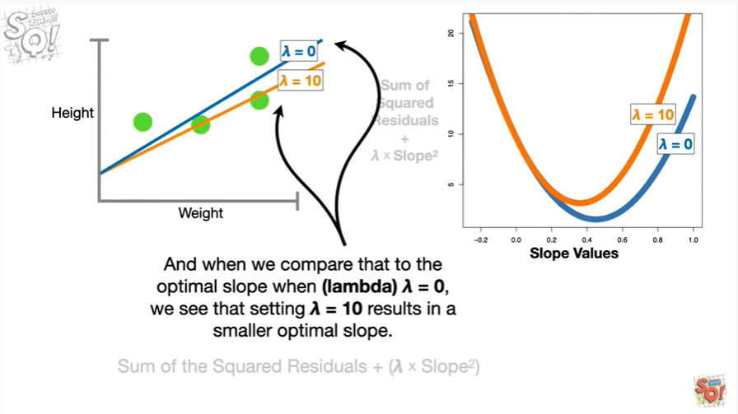

And when we compare that to the optimal slope when lambda equals zero, we see that setting lambda equal to ten results in a smaller optimal slope.

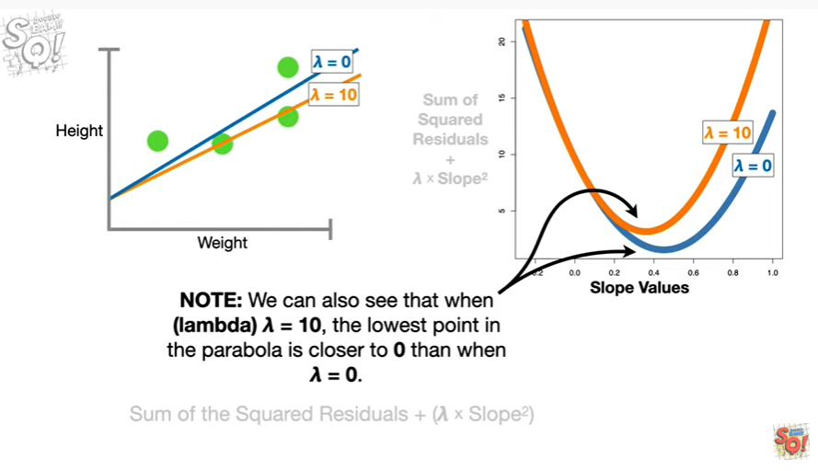

Note : we can also see that when lambda equals ten the lowest point in the parabola is closer to zero than when lambda equals zero.

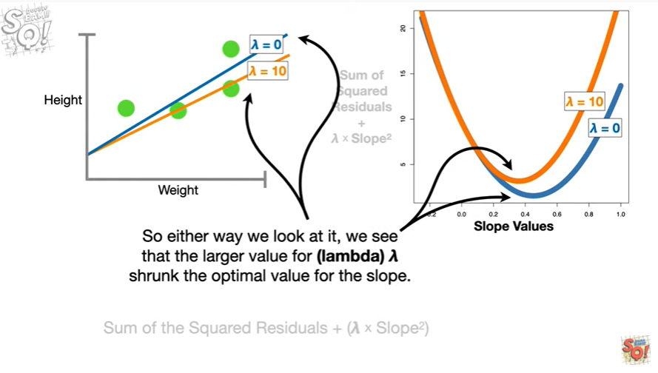

So either way we look at it we see that the larger value for lambda Shrunk the optimal value for the slope.

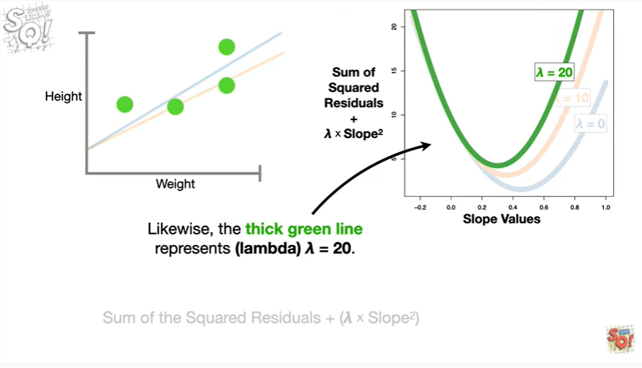

Likewise the thick green line represents lambda equals 20.

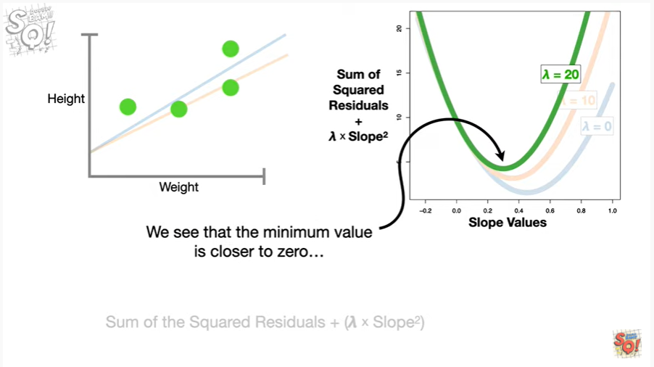

We see that the minimum value is closer to zero

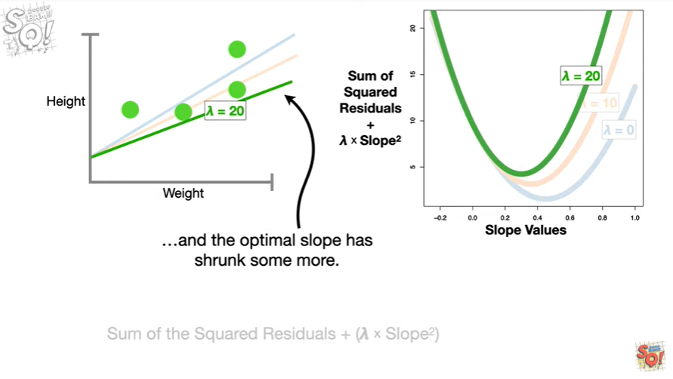

and the optimal slope has shrunk some more.

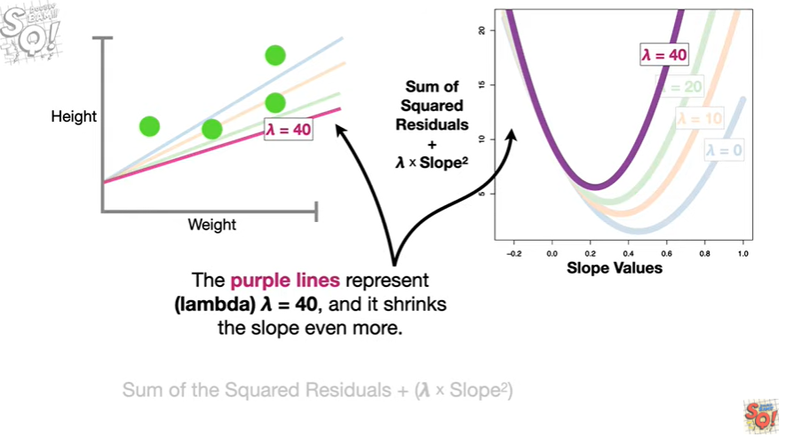

The purple lines represent lambda equals 40 and it shrinks the slope even more.

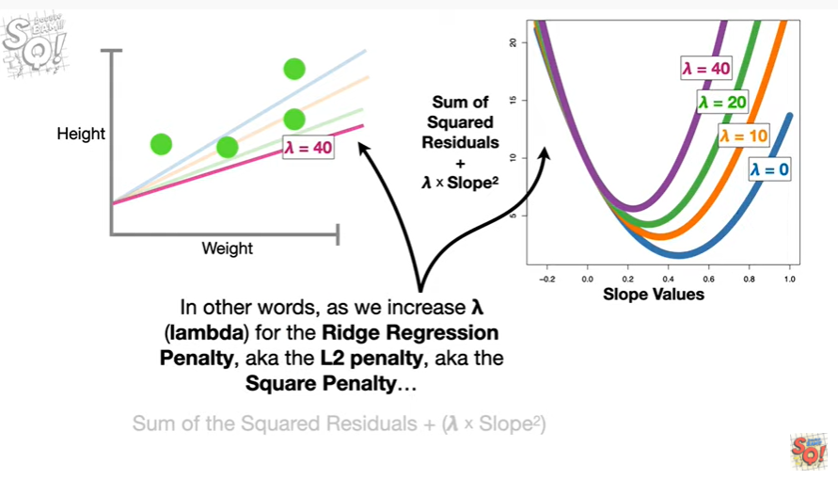

In other words as we increase lambda for the ridge regression penalty, aka the l2 penalty, aka the square penalty

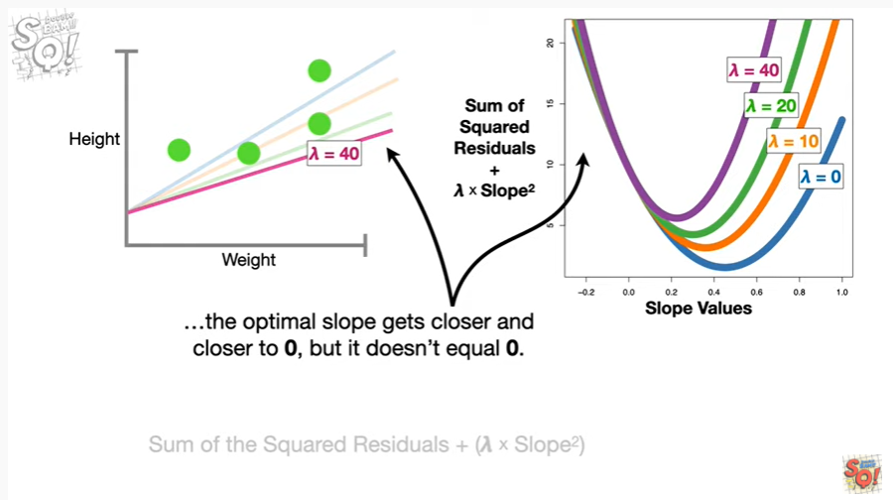

the optimal slope gets closer and closer to zero but it does not equal zero.

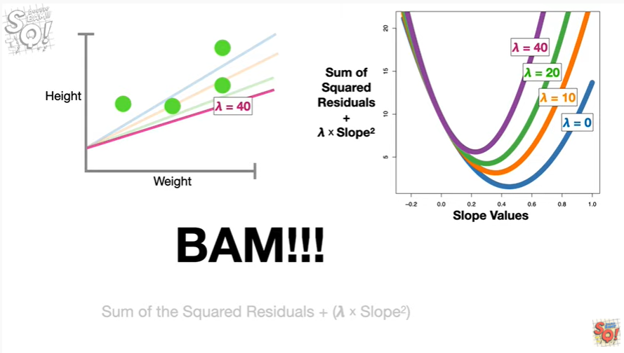

BAM !!!

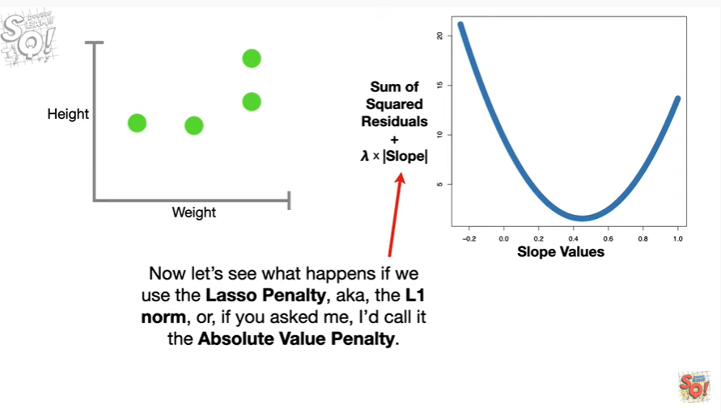

Now let's see what happens if we use the lasso penalty, aka the l1 norm or if you asked me I'd call it the absolute value penalty.

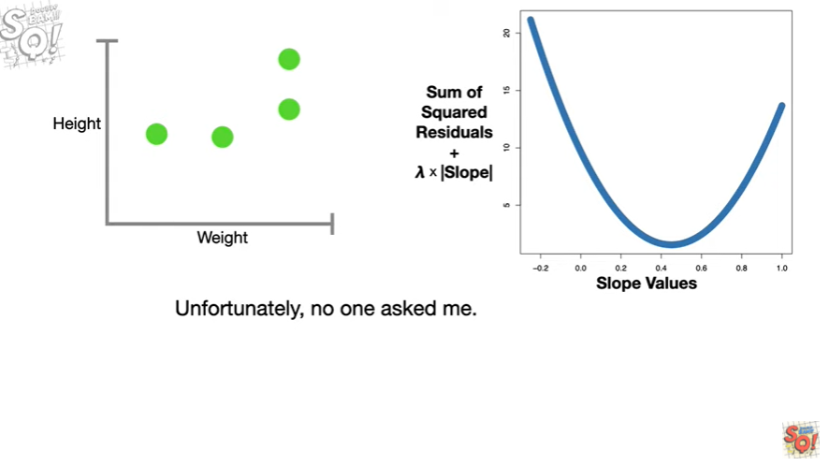

Unfortunately no one asked me.

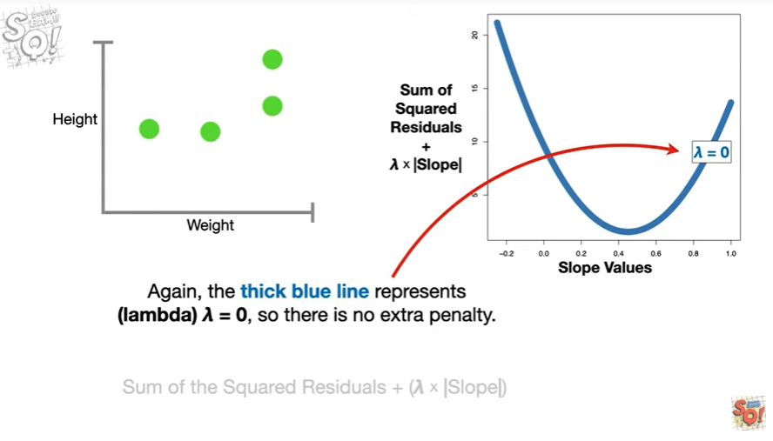

Again the thick blue line represents lambda equals zero so there is no extra penalty.

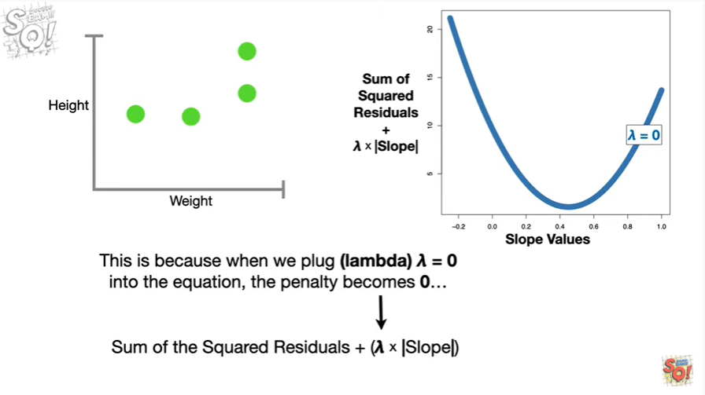

This is because when we plug lambda equals zero into the equation

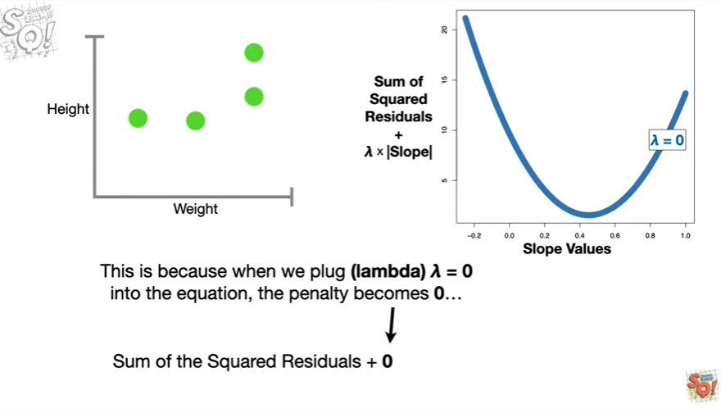

the penalty becomes zero

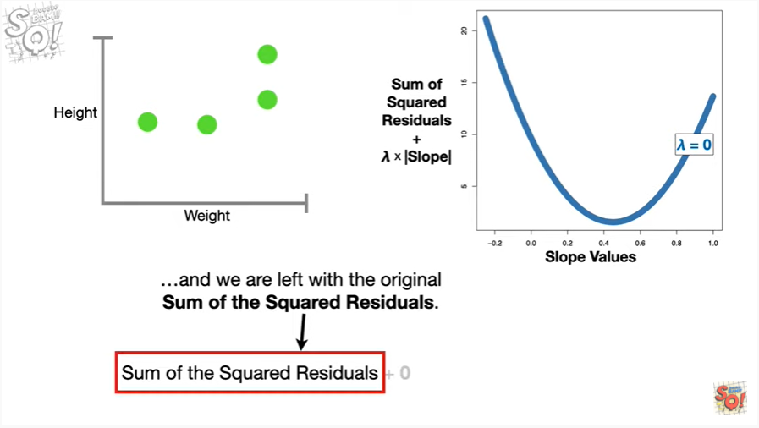

and we are left with the original sum of the squared residuals.

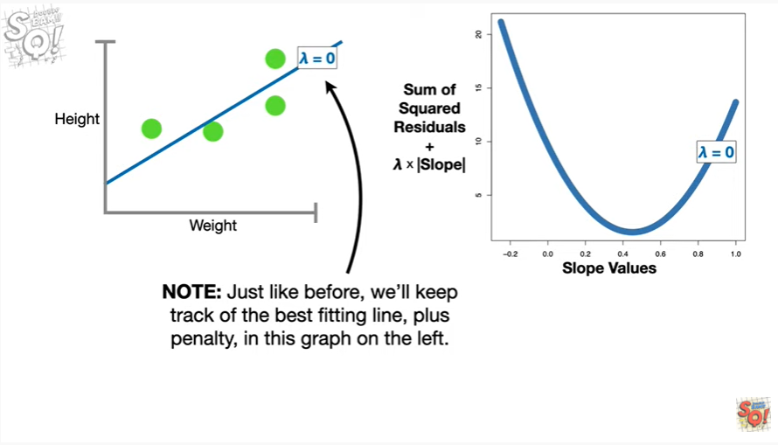

Note : just like before we'll keep track of the best fitting line plus penalty in this graph on the left.

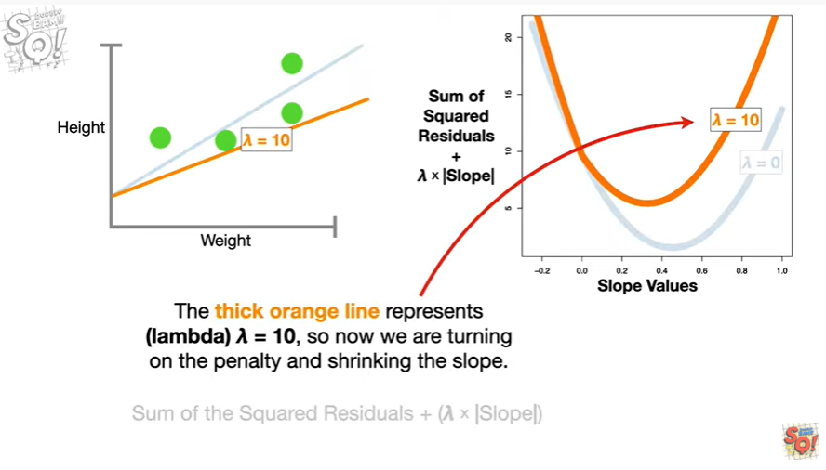

The thick orange line represents lambda equals 10 so now we are turning on the penalty and shrinking the slope.

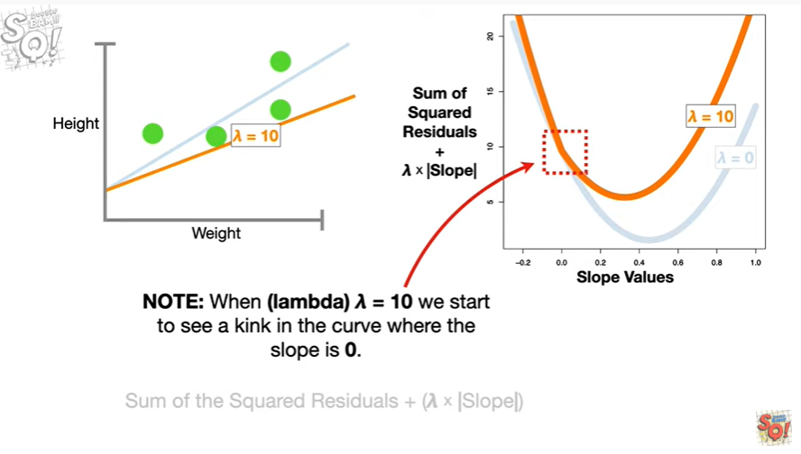

Note when lambda equals 10 we start to see a kink in the curve where the slope is zero.

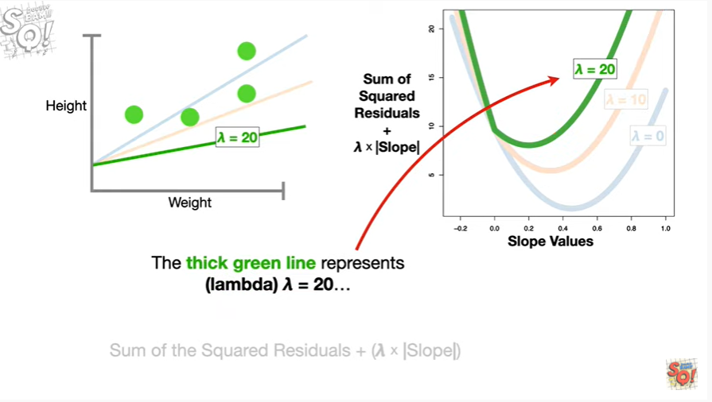

The thick green line represents lambda equals 20

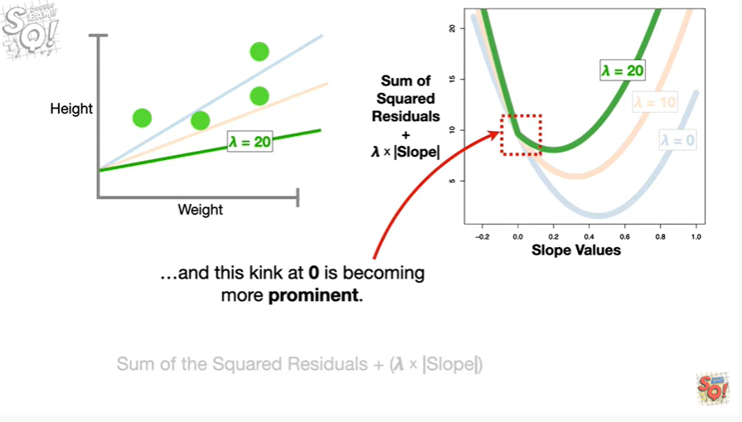

and this kink at zero is becoming more prominent.

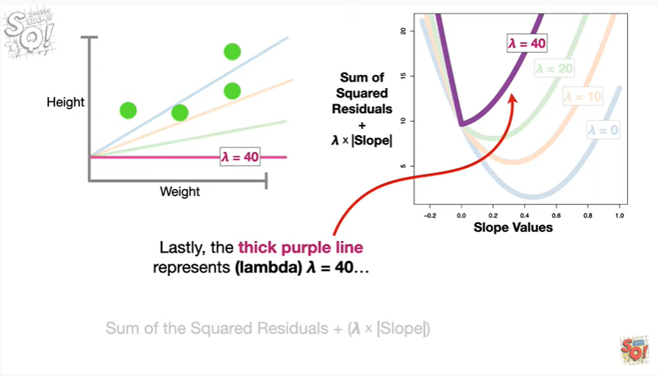

Lastly the thick purple line represents lambda equals 40

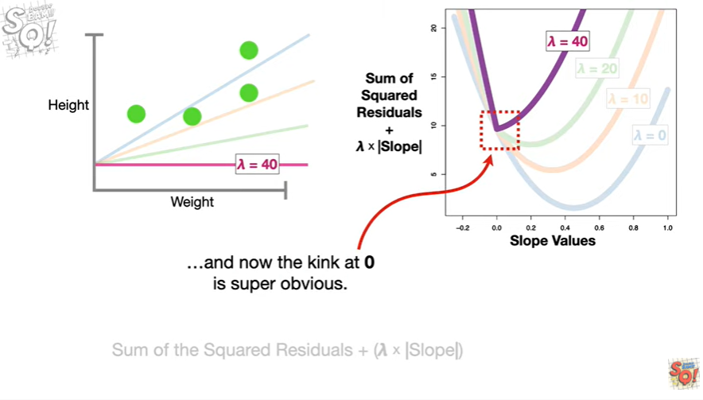

and now the kink at zero is super obvious.

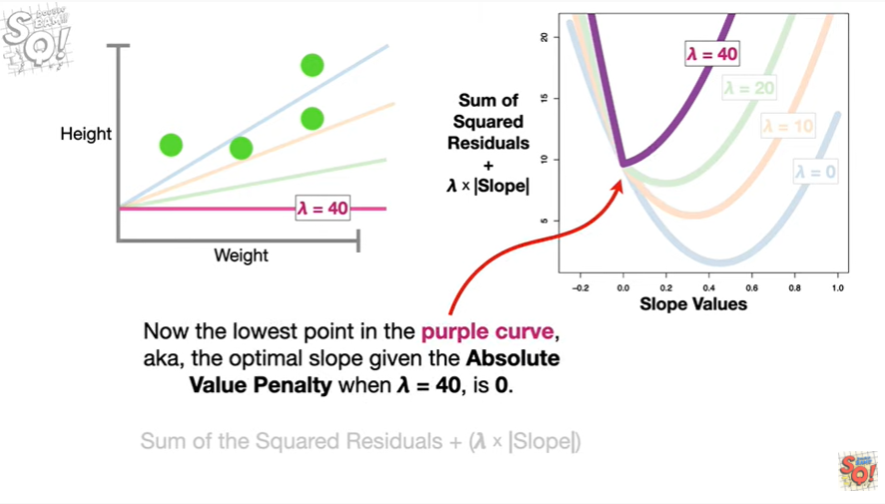

Now the lowest point in the purple curve aka the optimal slope given the absolute value penalty when lambda equals 40 is zero.

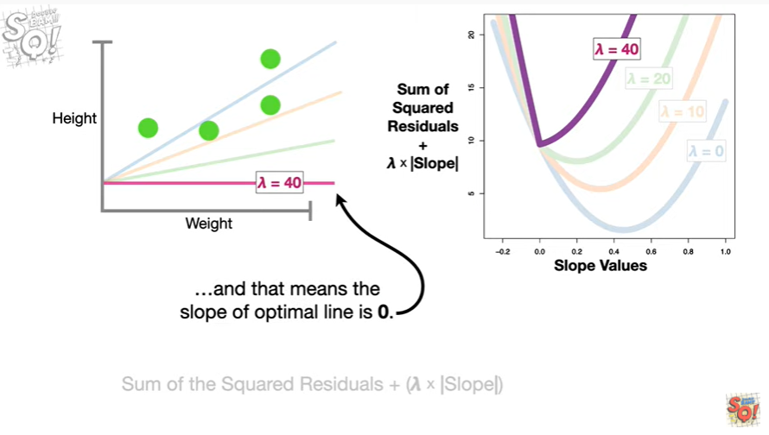

And that means the slope of the optimal line is zero.

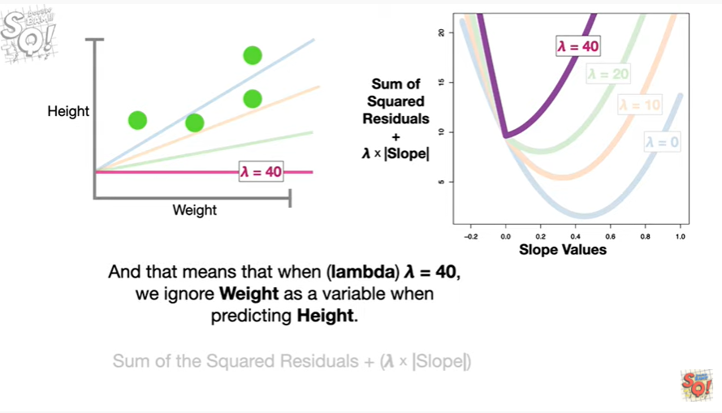

And that means when lambda equals 40 we ignore weight as a variable when predicting height.

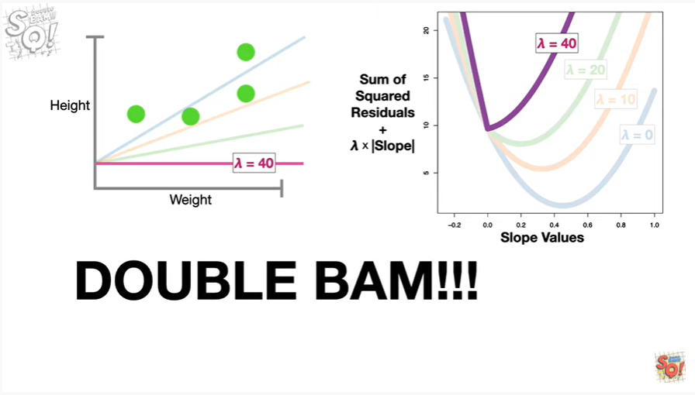

Double bam !!!



In summary :

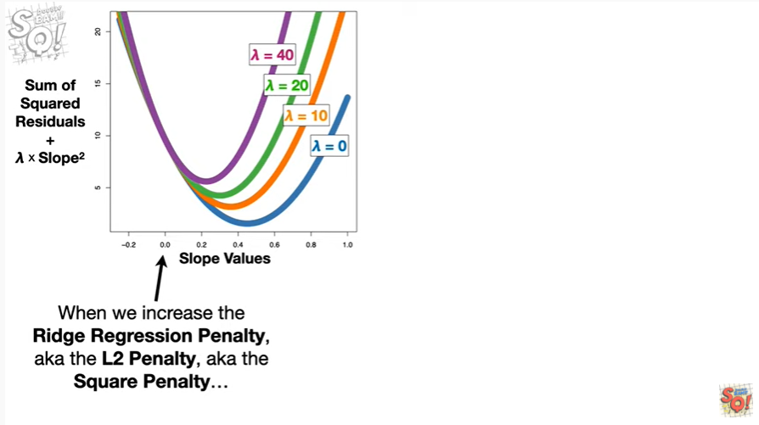

when we increase the Ridge regression penalty, aka the l2 penalty, aka the square penalty,

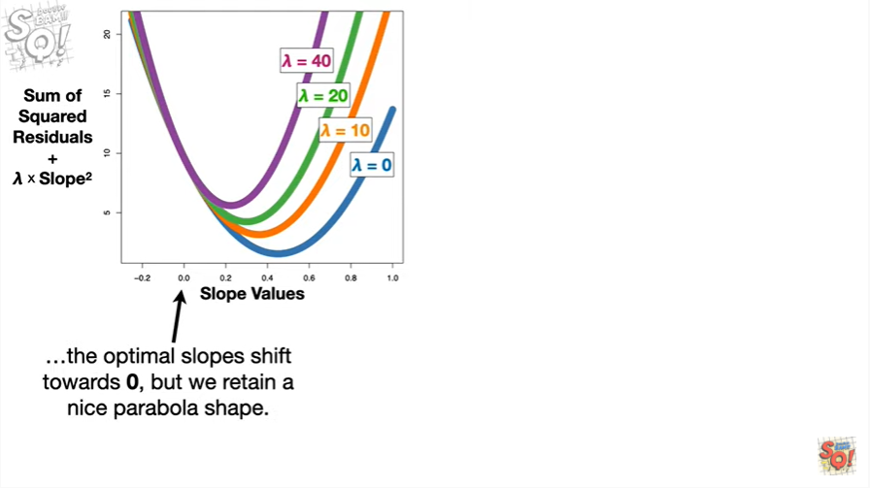

the optimal slopes shift towards zero but we retain a nice parabola shape.

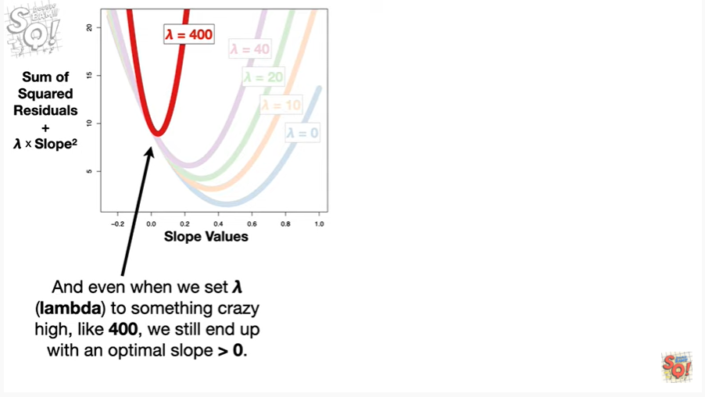

And even when we set lambda to something crazy high like 400 we still end up with an optimal value greater than zero.

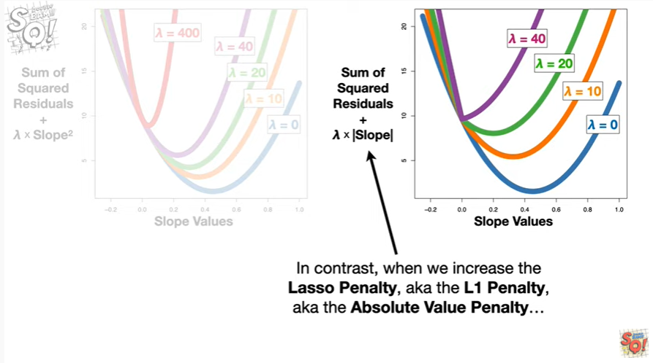

In contrast when we increase the lasso penalty, aka the l1 penalty, aka the absolute value penalty,

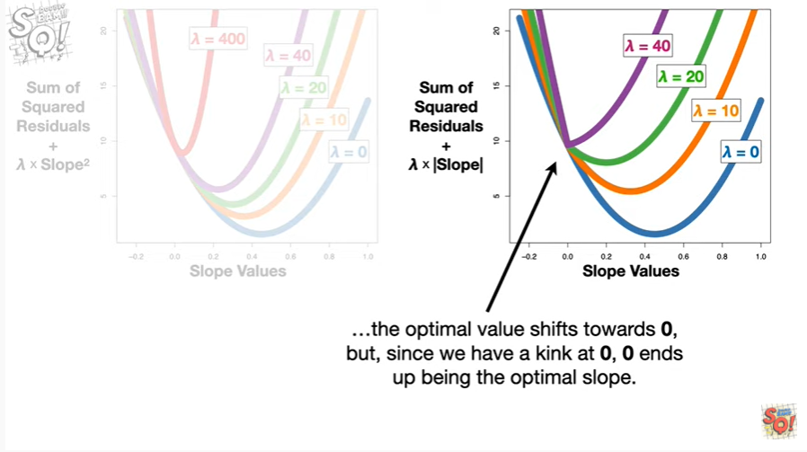

the optimal value shifts towards zero but since we have a kink at zero zero ends up being the optimal slope.

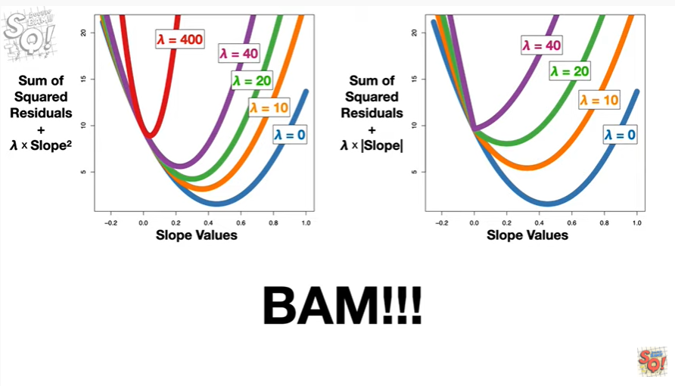

BAM !!!